

SHRI RAMDEOBABA COLLEGE OF ENGINEERING AND MANAGEMENT

**AUTONOMOUS BOT FOR WAREHOUSE/RETAIL**

A PROJECT REPORT

Submitted By

1.Aditi Vishwakarma

2.Priyal Sanklecha

3.Tanaya Kathale

4.Zainab Ali

5.Shreyas Kothari

6.Yash Kothari

Guided By

PROF.D.NAIDU MAM

**AIM**

To design and develop an autonomous bot for warehouse/retail.

**OBJECTIVE**

The objective of the project is to design and develop an autonomous bot, that could be used in a large retail store or warehouse to help with the following activity for a customer/employee:

* The bot should provide a user interface wherein the customer will enter the product name and the bot should determine in which aisle the product is located and travel to the spot. The customer/employee will follow the bot.

**ABSTRACT**

‘**DIVYAANG’(Deaf and Dumb)** or be it any normal customer ,when visits any retail shop ,it becomes difficult for them to locate the items they require and to shop with comfort. So thinking for better service to society our idea to develop a bot which shows direction of respective products and direct the customer towards them respectively. The bot will find the shortest optimal path towards each product (products that are entered by the user in mobile application), and direct the customer accordingly. It will get slower in the promotional zone.

Even in warehouses, where there are numerous products scattered in different racks, it is difficult to locate and manage these large quantities. Also the time consumption is very high for locating any particular product. This gave rise to the need of providing optimal solutions for finding shortest path from any particular product.

**CHALLENGES FACED AT WAREHOUSE:**

1. **Navigation in dynamic environments**

In warehouses, the environment is constantly changing due to the movement of products and shifting “walls” of boxes, which makes it challenging for robots to recognize their surroundings well enough to properly function and adapt. Objects can drastically vary in appearance or be remarkably similar, and must be differentiated in order for a robot to be able to recognize them to find its way around.

1. **Adapting to new variables and obstacles**

Everything is constantly on the move. People, crates, pallets, etc. appear in aisles frequently and without warning, presenting numerous obstacles for robots to navigate.

 Compounding the challenge, in even the best warehouse operations, items are often placed in a haphazard, unorganized way, and there’s no guarantee that an item is undamaged, in the correct place or that a database of inventory has been updated in anything approaching real-time. New SKUs come in all the time with a wide variety of shapes, sizes and weights – all of which present new variables that robots must learn and adapt to.

1. **Item manipulation**

Once a robot has overcome the challenges inherent in finding objects, it has to overcome the last major technical obstacle – getting an item off the shelf and to a box. Various robots have attempted to deal with the dynamic nature of items outlined above, but all have lacked a robust adaptive robotic system that is designed to handle the day-to-day challenges of item manipulation. Creating a robotic arm capable of handling a large variety of item sizes is very challenging, especially with cost constraints in mind. As a result, previous systems have required people to put cargo on and take cargo off robotic delivery systems, lessening automation.

**STATISTICS:**

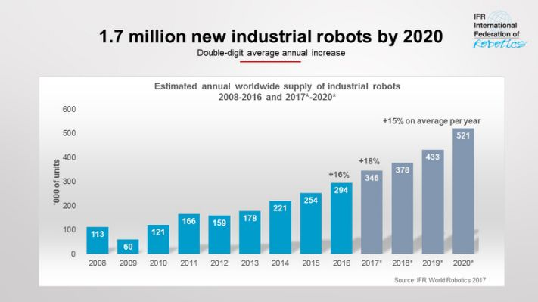

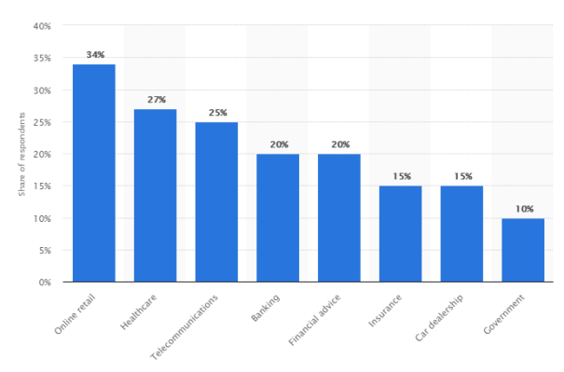

**TECHNOLOGY STACK:**

* Arduino: Working of bot

**Arduino** is an [open-source hardware](https://en.wikipedia.org/wiki/Open-source_hardware) and [software](https://en.wikipedia.org/wiki/Open-source_software) company, project and user community that designs and manufactures [single-board microcontrollers](https://en.wikipedia.org/wiki/Single-board_microcontroller) and [microcontroller](https://en.wikipedia.org/wiki/Microcontroller) kits for building digital devices. Its products are licensed under the [GNU Lesser General Public License](https://en.wikipedia.org/wiki/GNU_Lesser_General_Public_License) (LGPL) or the [GNU General Public License](https://en.wikipedia.org/wiki/GNU_General_Public_License) (GPL),[[1]](https://en.wikipedia.org/wiki/Arduino#cite_note-1) permitting the manufacture of Arduino boards and software distribution by anyone. Arduino boards are available commercially in preassembled form or as [do-it-yourself](https://en.wikipedia.org/wiki/Do-it-yourself) (DIY) kits.

Arduino board designs use a variety of [microprocessors](https://en.wikipedia.org/wiki/Microprocessor) and controllers. The boards are equipped with sets of digital and analog input/output (I/O) pins that may be interfaced to various expansion boards or [breadboards](https://en.wikipedia.org/wiki/Breadboards) (*shields*) and other circuits. The boards feature serial communications interfaces, including [Universal Serial Bus](https://en.wikipedia.org/wiki/Universal_Serial_Bus) (USB) on some models, which are also used for loading programs from personal computers. The microcontrollers can be programmed using [C](https://en.wikipedia.org/wiki/C_(programming_language)) and [C++](https://en.wikipedia.org/wiki/C%2B%2B) [programming languages](https://en.wikipedia.org/wiki/Programming_language). In addition to using traditional [compiler](https://en.wikipedia.org/wiki/Compiler) [toolchains](https://en.wikipedia.org/wiki/Toolchains), the Arduino project provides an [integrated development environment](https://en.wikipedia.org/wiki/Integrated_development_environment) (IDE) based on the [Processing](https://en.wikipedia.org/wiki/Processing_(programming_language)) language project.

The Arduino project started in 2005 as a program for students at the [Interaction Design Institute Ivrea](https://en.wikipedia.org/wiki/Interaction_Design_Institute_Ivrea) in [Ivrea](https://en.wikipedia.org/wiki/Ivrea), Italy,[[2]](https://en.wikipedia.org/wiki/Arduino#cite_note-kushner-2) aiming to provide a low-cost and easy way for novices and professionals to create devices that interact with their environment using [sensors](https://en.wikipedia.org/wiki/Sensor) and [actuators](https://en.wikipedia.org/wiki/Actuator). Common examples of such devices intended for beginner hobbyists include simple [robots](https://en.wikipedia.org/wiki/Robot), [thermostats](https://en.wikipedia.org/wiki/Thermostat) and [motion detectors](https://en.wikipedia.org/wiki/Motion_detector).

The name *Arduino* comes from a bar in [Ivrea](https://en.wikipedia.org/wiki/Ivrea), Italy, where some of the founders of the project used to meet. The bar was named after [Arduin of Ivrea](https://en.wikipedia.org/wiki/Arduin_of_Ivrea" \o "Arduin of Ivrea), who was the [margrave](https://en.wikipedia.org/wiki/Margrave) of the [March of Ivrea](https://en.wikipedia.org/wiki/March_of_Ivrea) and [King of Italy](https://en.wikipedia.org/wiki/King_of_Italy) from 1002 to 1014.[[3]](https://en.wikipedia.org/wiki/Arduino#cite_note-3)

* Android Studio: To create mobile application

**Android Studio** is the official[[7]](https://en.wikipedia.org/wiki/Android_Studio#cite_note-7) [integrated development environment](https://en.wikipedia.org/wiki/Integrated_development_environment) (IDE) for [Google](https://en.wikipedia.org/wiki/Google)'s [Android](https://en.wikipedia.org/wiki/Android_(operating_system)) [operating system](https://en.wikipedia.org/wiki/Operating_system), built on [JetBrains](https://en.wikipedia.org/wiki/JetBrains" \o "JetBrains)' [IntelliJ IDEA](https://en.wikipedia.org/wiki/IntelliJ_IDEA) software and designed specifically for [Android development](https://en.wikipedia.org/wiki/Android_software_development).[[8]](https://en.wikipedia.org/wiki/Android_Studio#cite_note-8) It is available for download on [Windows](https://en.wikipedia.org/wiki/Windows), [macOS](https://en.wikipedia.org/wiki/MacOS" \o "MacOS) and [Linux](https://en.wikipedia.org/wiki/Linux) based operating systems.[[9]](https://en.wikipedia.org/wiki/Android_Studio#cite_note-9)[[10]](https://en.wikipedia.org/wiki/Android_Studio#cite_note-10) It is a replacement for the [Eclipse Android Development Tools](https://en.wikipedia.org/wiki/Eclipse_(software)#Android_Development_Tools) (ADT) as the primary IDE for native Android application development.

Android Studio was announced on May 16, 2013 at the [Google I/O](https://en.wikipedia.org/wiki/Google_I/O) conference. It was in early access preview stage starting from version 0.1 in May 2013, then entered beta stage starting from version 0.8 which was released in June 2014.[[11]](https://en.wikipedia.org/wiki/Android_Studio#cite_note-11) The first stable build was released in December 2014, starting from version 1.0.[[12]](https://en.wikipedia.org/wiki/Android_Studio#cite_note-12)

Since 7 May 2019, [Kotlin](https://en.wikipedia.org/wiki/Kotlin_(programming_language)" \o "Kotlin (programming language)) is Google’s preferred language for Android app development.[[13]](https://en.wikipedia.org/wiki/Android_Studio#cite_note-13) Still, other languages are supported, including by Android Studio.

* Google firebase: The database of mobile application

Firebase evolved from Envolve, a prior startup founded by James Tamplin and Andrew Lee in 2011. Envolve provided developers an API that enables the integration of online chat functionality into their websites. After releasing the chat service, Tamplin and Lee found that it was being used to pass application data that weren't chat messages. Developers were using Envolve to sync application data such as game state in real time across their users. Tamplin and Lee decided to separate the chat system and the real-time architecture that powered it.[[8]](https://en.wikipedia.org/wiki/Firebase#cite_note-8) They founded Firebase as a separate company in September 2011[[1]](https://en.wikipedia.org/wiki/Firebase#cite_note-crunch2011-1) and it launched to the public in April 2012. Firebase's first product was the Firebase Real-time Database, an API that synchronizes application data across iOS, Android, and Web devices, and stores it on Firebase's cloud. The product assists software developers in building real-time, collaborative applications.

**WORKING**

* **Bot**
* The customer inputs the list of required products in the mobile application.
* The bot will accept the input through **BLUETOOTH SENSORS.**
* It uses **A* algorithm** to find shortest optimal path from the source node and **TSP** to traverse , for all the products and choose the minimum distance path.
* After reaching the first item, that position will become the source and the process continues until the list becomes empty.
* The bot stops and again searches for the product having shortest optimal distance, on addition/removal of any product by the customer in between.
* It detects the obstacles through sonic sensors and takes the decision accordingly.
* The bot gets slow in the promotional zone.

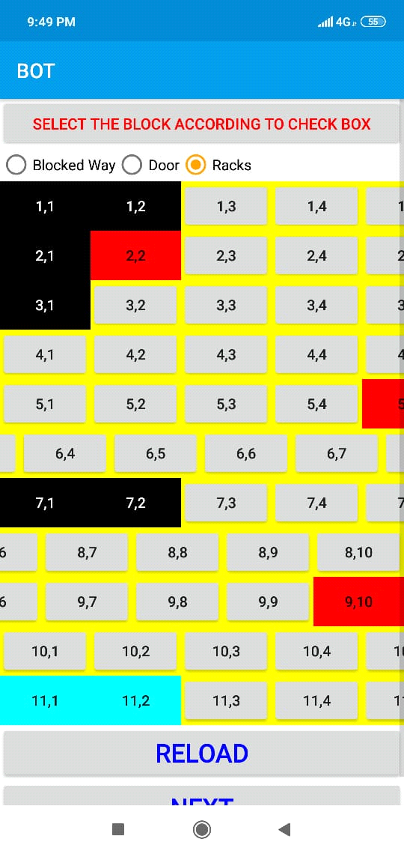 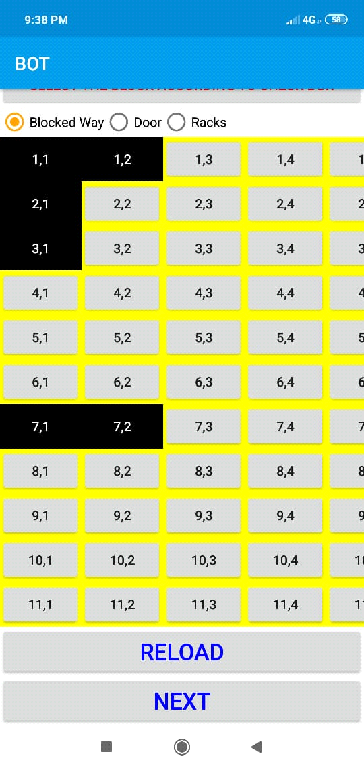

* **Mobile Application**

**ADMIN PROCESS:**

* Dynamic grid formation.
* Dynamically specifying the position of the racks in the generated grid.
* Addition of products in the rack.
* Dynamic addition/removal/updation of products.
* Timely updation the offers.

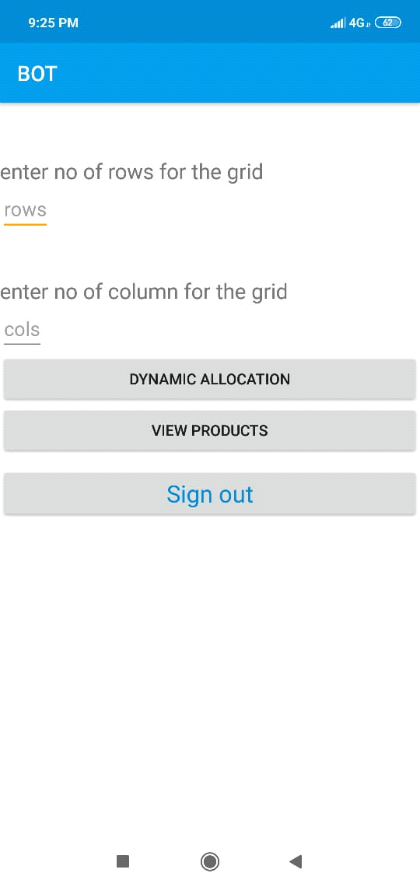 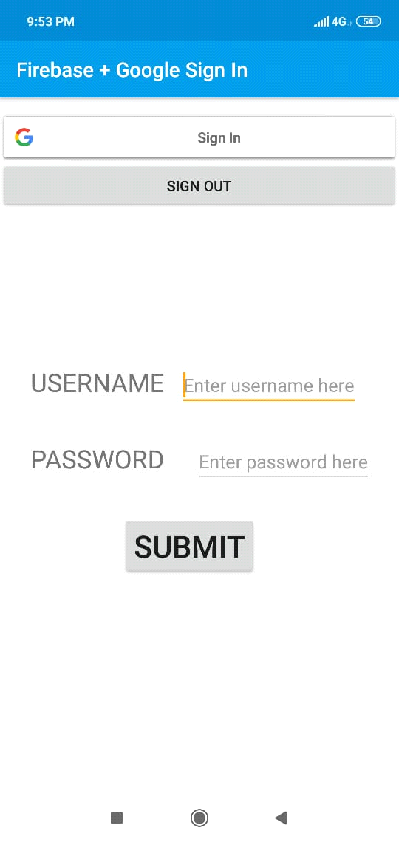 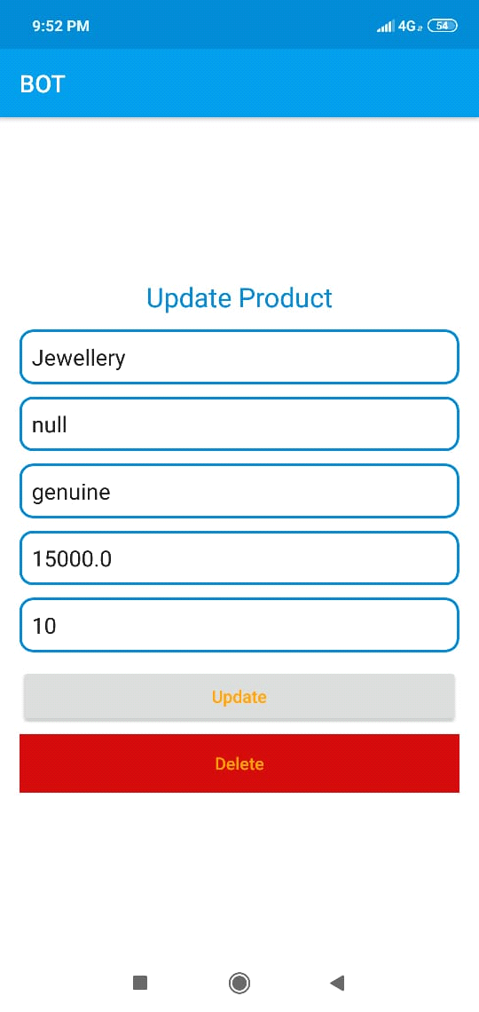

**CUSTOMER PROCESS:**

* Selection of urgent/non-urgent shopping.
* Dynamic addition or removal of the products if required from the cart.
* Give commands to the bot through the mobile application.

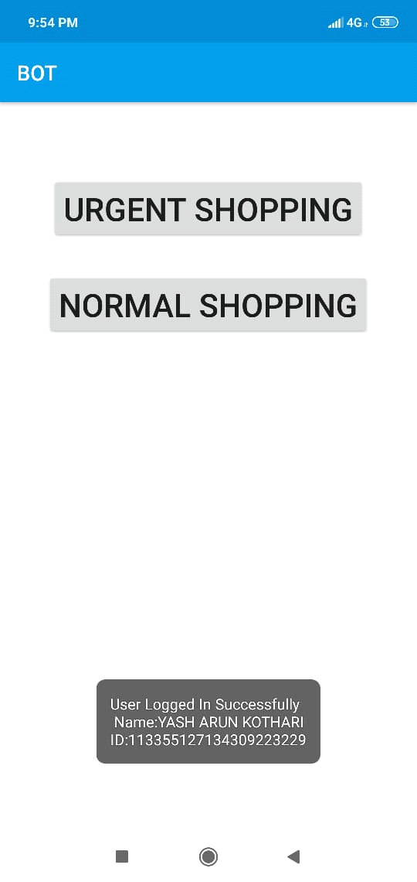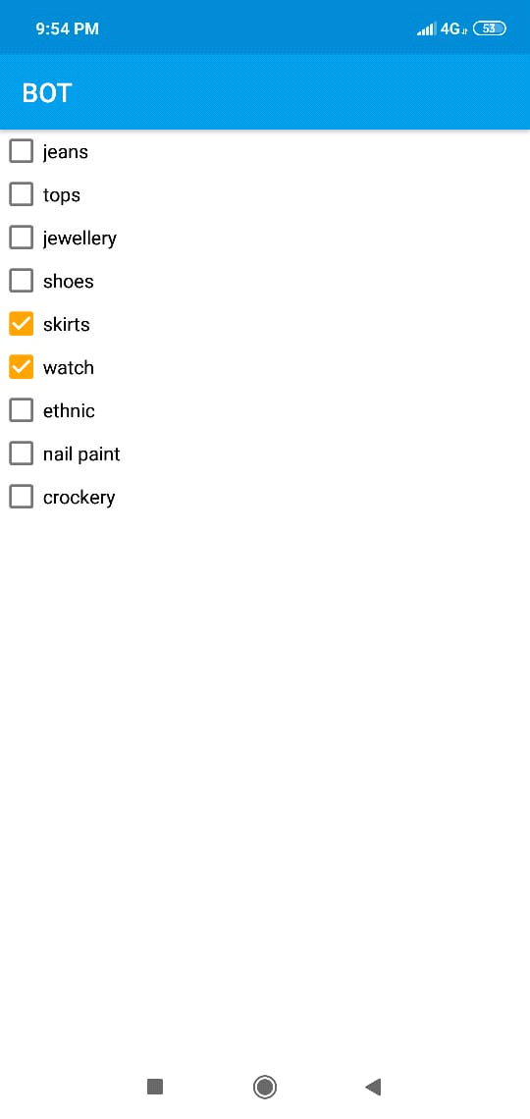

**SCOPE AND FUTURE APPLICATIONS**

* As our project aims to find shortest path for the products and directing the customer/employee towards the apt location, this can be highly useful in big warehouses and retail.
* Since the complexity will be less as it finds the shortest optimal path and being very cost-efficient , it is very practical to use.

**APPLICATIONS:**

* Improved efficiency
* Minimal processing errors
* Expedited movement of goods within the warehouse and across the supply chain
* Tedious tasks automated by robots
* Human resources redirected to more complex tasks
* Workplace injuries reduced
* Simulation of shops and warehouses

**LITERATURE REVIEW**

[**http://ieeexplore.ieee.org/stamp/stamp.jsp?tp=&arnumber=5538330&isnumber=5538207**](http://ieeexplore.ieee.org/stamp/stamp.jsp?tp=&arnumber=5538330&isnumber=5538207)

[**http://ieeexplore.ieee.org/stamp/stamp.jsp?tp=&arnumber=7737288&isnumber=7737185**](http://ieeexplore.ieee.org/stamp/stamp.jsp?tp=&arnumber=7737288&isnumber=7737185)